

Configuration Management Plan

Farmer Plus

Version 1.2

TEAM:
Syed Qasim Ifzal
Muhammad Zubair
Amber Shahid
Tahir Rauf
ADVISOR:
Mr. Waqas Ahmed
Revision Sheet

Release No. | Date | Author | Revision Description
1. 0 | 24/9/2010 | Amber Shahid | Configuration Management Plan and Checklist
1.1 | 26/9/2010 | Tahir Rauf | CCB changes Made, Process revised
1.2 | 27/9/2010 | - Amber Shahid  - Tahir Rauf | Final Review made

CONFIGURATION MANAGEMENT PLAN

TABLE OF CONTENTS

1.0 GENERAL INFORMATION 1-1
1.1 Purpose 1-1
1.2 Scope 1-1
1.3 Project References 1-2
1.4 Acronyms and Abbreviations 1-2
1.5 Points of Contact 1-2
2.0 CONFIGURATION CONTROL 2-1
2.1 Change Control Board (CCB) 2-1
2.2 Configuration Items 2-2
2.3 Baseline Identification 2-2
2.3.1 Functional Baseline 2-3
2.3.2 Design Baseline 2-3
2.3.3 Development Baseline 2-3
2.3.4 Product Baseline 2-3
2.4 Roles and Responsibilities 2-3
3.0 Change Control Process 3-1
3.1 Change Classifications 3-1
3.2 Change Control Forms 3-2
Request Description 3-3
Justification0 3-3
Alternative Solutions 3-3
Impact Assessment 3-3
Impacts 3-3
Option 1 3-3
Option 2 3-3
Option 3 3-3
Recommendation 3-4
Authorization 3-4
3.3 Problem Resolution Tracking 3-5
3.4 Configuration Status Accounting (CSA) 3-5
3.5 Configuration Audits 3-6
3.5.1 Functional Configuration Audit 3-6
3.5.2 Physical Configuration Audit 3-6
3.6 Tools 3-6
4.0 TRAINING 4-1

1.0 GENERAL INFORMATION

GENERAL INFORMATION

1.1 Purpose
Configuration Management (CM) is the ongoing process of identifying and managing changes to deliverables and other work products. The Configuration Management Plan (CM Plan) is developed to define, document, control, implement, account for, and audit changes to the various components of this project. The CM Plan provides information on the requirements and procedures necessary for CM activities. It identifies CM requirements and establishes the methodology for configuration identification and control of releases and changes to configuration items. It also describes the process for maintaining status accounting and verifying the completeness and correctness of configuration items throughout the system lifecycle.

This document, the Configuration Management Plan, describes our plan for tracking the configuration of elements of the developed system and managing change throughout the lifecycle of the project. It defines the policies and procedures for configuration management (CM) and the infrastructure necessary to implement them throughout the project.

1.2 Scope
The following sections have been defined for the “Farmer +” program:

Section 1 gives the introduction, scope, references of the document. Also, it mentions the points of contact who may be needed for help.

Section 2 describes the Configuration Control mechanism to be followed including the system evaluation, coordination, approval or disapproval, and implementation of all proposed changes. Also, it discusses the roles and responsibilities of the Change Control Board, the interaction between the CCB and the project management. Moreover, it will describe the configuration items used and the baselines finalized.

Section 3 caters to the change control process; problem resolution strategies, configuration audits, release management strategies, format and contents of the status summary reports that will be produced by the CSA function.

Section 4 deals with the approach that will be followed for trainings.

1.3 Project References

Provide a list of the references that were used in preparation of this document.

- Farmer+ Bid Proposal document
- Configuration Management Template
- SCM in Agile Methods by Koskela

1.4 Acronyms and Abbreviations

CCB: Change control Board
CI: Configuration Item

1.5 Points of Contact

For any sort of confusion the Farmer+ team, including the following members, is available to answer any queries via emails, skype, meeting or via a phone call:
- Mr. Qasim Ifzal – (l080969@lhr.nu.edu.pk)
- Mr. Muhammad Zubair – (l080808@lhr.nu.edu.pk)
- Ms. Amber Shahid – (l095061@lhr.nu.edu.pk)
- Mr. Tahir Rauf - (tahir.abdul.rauf@gmail.com)

2.0 CONFIGURATION CONTROL

CONFIGURATION CONTROL

Once it is time to place items under configuration control, the Configuration Manager will assign a name to the Configuration Item. The item will be checked into the project repository using that name. Also, a version number will be assigned to each configuration Item when it is first checked into the system.
This version number may be later used to access this configuration Item using its label/tag.

The developers can check out the CI, make changes, and commit them back to the repository. The developer will attempt to accurately describe the changes in the log entered with each commit. Preferably, one developer at a time will be able to check out a CI, if a need arises it may be branched for concurrent work without clashes.

Developers are encouraged to unit test the work prior to commit and only commit the changes when the software as a whole is in a working state.

When making a significant number of changes, which require commits prior to the system working, the use of “branches” can help track the changes without impacting the work of other developers of the same CI.

A ChangeLog/History will list the version baselines of the CI by tags and briefly summarize the changes to the CI represented by that baseline.

2.1 Change Control Board (CCB)

The Change Control Board (CCB) is a project-level, decision-making body that must approve or disapprove all change control requests before they can be implemented. For this project the CCB will consist of:
- Mr. Waqar Ahmed – Customer/ Advisor
- Mr. Qasim Ifzal – Project Manager
- Mr. Muhammad Zubair – Lead Developer & Tester
- Ms. Amber Shahid – Quality Assurance Manager & Risk Officer
- Mr. Tahir Rauf - Lead Developer & Configuration Manager

Any change that affects the base-lined requirements must be submitted to the CCB as a Configuration
Change Request. The CCB will analyze and consider each new change request. If the request is rejected, it may be reworked and resubmitted. If it is accepted, the requirements will be re-baselined and everyone potentially affected by the change will be informed. A change in requirements will trigger updates to the design (and design documentation) and implementation as appropriate.

2.2 Configuration Items

Configuration items (CI) are the products that are to be placed under configuration control. For our project these include:

- Software Requirements Specifications
- Software Functional Specifications
- Risk Management Plan
- SQA Plan
- Test Plan
- Software Development Plan
- Software Configuration Management Plan
- Project Plan
- Usability cycle guide
- Application Code
- Design Specification Document
- Design Review Report
- Code Review Report
- Risk Analysis Report
- Software Requirement Specifications – Quality report
- Test Plan – Quality Report

2.3 Baseline Identification
This is the basic life cycle we will be using for Base-lining.

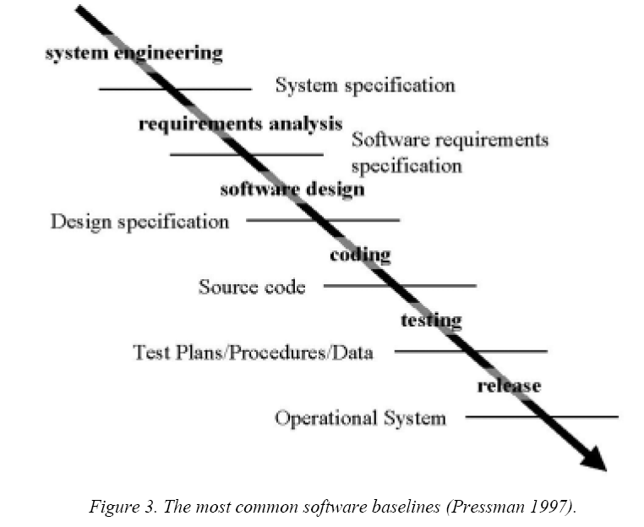

2.3.1 Functional Baseline
Software requirements Specification Document & Software Functional Specifications Document will serve as the Functional Baselines. These documents will be finalized after meetings with all concerned stakeholders and once accepted by the user these will be our baselines.

Using Web Subversion (SVN), configuration items will be loaded into the repository and will be marked as a baseline by the Configuration Officer.

2.3.2 Design Baseline

Design Specification Document once finalized after quality review will serve as the Design Baseline. These documents will be finalized after meetings with all team members.

Using Web Subversion (SVN), configuration items will by any of the team members into the repository and will be marked as a baseline by the Configuration Officer.

2.3.3 Development Baseline

Source code will serve as the Development Baseline once finalized after code review.

Using Web Subversion (SVN), configuration items will be loaded into the repository loaded by developers and will be marked as a baseline by the Configuration Officer.

2.3.4 Product Baseline

When the acceptance testing is complete and the product has been accepted by the advisor, the product baseline will be established.

2.4 Roles and Responsibilities

Project Manager (PM)
The Project Manager has ultimate responsibility for all activities and will be informed and involved about major CM releases and decisions.

Configuration Manager (CM)
The Configuration Manager will be responsible for overall management of the configuration management repository and identification of configuration items (CIs) to be managed. Basically his tasks would include:

- managing the efforts of the project related to Configuration Management
- Call and chair all Configuration Control Board (CCB) meetings;
- Record the disposition of all Change Requests for purposes of configuration status accounting and reporting; and
- Assign identifiers to all configuration items
Developer
Each of the developers can check out, make changes, and commit changes to the CI as needed.

CCB
A Configuration Control Board (CCB) comprised of the Project Manager, the Configuration Manager, and the team involved in our case will make decisions regarding major changes as needed. This board will meet when ever the Configuration Manager feels a need to arrange a meeting of the members. Any changes to the requirements must be approved by the CCB.

3.0 CHANGE CONTROL PROCESS

Change Control Process

3.1 Change Classifications

Whenever a change request is placed thorough the Change Request Form (Appendix 11.1), all the members of the CCB will approve the change request as follows:
- Require formal (written) requests for all changes.
- Review all change requests, approve or reject changes and limit changes to those approved.
- Analyze and evaluate the following factors involved when considering change requests:
- Type & frequency of change
- Criticality – degree to which change is needed
- Interface requirements
- Compatibility with design
- Change sensitivity
- Schedule
- Ownership
- Cost benefit analysis
- Scope and complexity

- Emphasize the need to determine whether a proposed change will enhance or degrade the system.
- Schedule all changes.
- Enforce documentation standards.
- Plan for change.

This is the methodology that will be followed by the CCB for approval or rejection of any change.
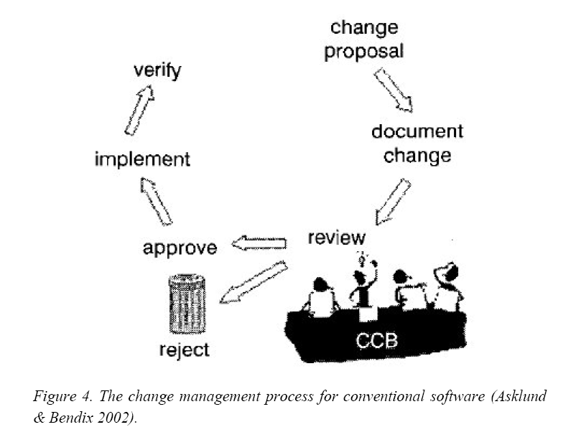

3.2 Change Control Forms

On the next page is the sample Change request form that will be used for any change requirement:
Request No: |  | Request Date:
Request Title: |  | Status:
Originator's Name: |  | Phone/Email:
Sponsor's Name: |  | Priority:
Assigned To: |  | Response Date:

Request Description

Justification

Alternative Solutions
1.

2.

3.

Impact Assessment
Impacts | Option 1 | Option 2 | Option 3
Functional Scope
Schedule
Effort
Cost

Recommendation

Authorization
Action: |  | Authorized By: |  | Date:

3.3 Problem Resolution Tracking

In case of any problems occurring with Configuration management, all such issues will ne escalated to the Configuration Manager who will then find the appropriate resolution strategy for the problem in hand.

3.4 Configuration Status Accounting (CSA)

The tasks involved are:
- Record the status summary reports
- Record the current approved configuration documentation and configuration identifiers associated with each systems/CI(s).
- Record and report the status of proposed software changes from initiation to final approval to implementation.
- Record and report the results of configuration audits to include the status and final disposition of identified discrepancies and action items.
- Record and report implementation status of authorized changes
- Provide the traceability of all changes from the original released configuration documentation of each System/CI(s).
- Report the effectiveness and installation status of configuration changes to all system/CI(s).

3.5 Configuration Audits

3.5.1 Functional Configuration Audit

The FCA will verify that:

• The development of a configuration item has been completed satisfactorily
• The item has achieved the performance and functional characteristics specified
• Its operational and support documents are complete and satisfactory

The FCA Checklist will include about 15 questions such as the following:

- Have standards been identified to clearly define this process?
- Were guidelines used to prepare for the process?
- Has the project submitted any request for deviations or waivers to the defined process?
- Have entrance and exit criteria been established for the implementation of this process?
- Have all parties involved in the implementation of the assessed process received
- Has the FCA verified that the configuration item has achieved the requirements specified in its functional baseline documentation and identified /recorded any discrepancies.

3.5.2 Physical Configuration Audit

The PCA will verify that:
• All items identified as being part of the configuration are present in the product baseline
• The correct version and revision of each part are included in the product baseline
• They correspond to information contained in the baseline’s configuration status report

The FCA Checklist will include about 15 questions such as the following:
- Has each nonconformance or noncompliance from the FCA been appropriately resolved?
- Have all of the identified Configuration Items (e.g., source code, documentation, etc.) been base lined?
- Do all of the Configuration Items meet workmanship standards?
- Has the software been built from the correct components and in accordance with the specification?
- Is the deliverable documentation set complete?

3.6 Tools

Web SVN will be used for Configuration Management. Its basic features are:

- Easy-to-use interface, simple to install / configure
- Supports multiple repositories, local or remote
- Optional path-based restriction of privileges
- Colourisation of file listings; MIME type support
- Blame (annotation) view of file authorship
- Comparing revisions of files / directories
- Revision and log message browsing / searching
- RSS feed support for watching any resource
- Download of files and folders
- Customizable templating system
- Multiple languages and on-demand switching

4.0 TRAINING

TRAINING

The entire team will be trained by the Configuration Officer as to how to use WebSVN for their respective work and how the processes mentioned above will be followed.

